CS3235 Course Project — Requirements Document
Helping Eyes · Working with Large Language Models (LLMs) · Version 0.2 · 26 September 2026

1. Project overview
Field | Details
Project title | Helping Eyes — Camera-Based Reading Assistant for Visually Impaired Users
Team ID | [Team ID]
Team members (name, roll no., role) | [Name — Roll no. — Role, one line per member]
Faculty mentor | [Faculty mentor name]
Primary course module | 3 · Multimodal (camera images, text and speech), with tool use from Module 2 (Agents) for the consent-based web lookup
Version / date | v0.2, 26-09-2026

Problem statement (3–5 sentences): Visually impaired people depend on printed text every day — medicine packs, food labels, letters, bills and books — but cannot read it independently. Commercial reading aids are expensive and need dedicated hardware, and phone OCR apps usually read every word aloud, so the user must listen to an entire label to find one detail such as a dosage or an expiry date. Classical OCR pipelines also struggle with the conditions of hand-held use: blur, tilted or curved pages, two-page book spreads and running headers that are read in the middle of the text.
Why an LLM? Users ask open-ended, spoken questions about arbitrary text ("How many can a ten-year-old take?", "Read only the warning", "Can I use it on a burn?"). Answering requires understanding the question, locating and quoting the relevant part of noisy OCR text, and phrasing a short spoken answer — which rule-based keyword matching cannot do across the variety of labels and documents. Tasks that do have exact answers are deliberately kept out of the LLM: full read-out is spoken directly from the OCR text, and expiry dates are compared with today's date in code, because the 7B model was observed to get date comparisons wrong.
One-line solution summary: A camera-based reading assistant that helps visually impaired people to get exactly the information they need from labels, documents and books by using on-device text recognition (Apple Vision), a local large language model (Qwen 2.5 7B Instruct) and speech.

2. Scope and users
In scope — what the finished system will do:
- Live text detection with spoken positioning guidance ("Move closer", "Move left") and automatic capture from a USB or built-in webcam.
- Spoken and typed requests about the captured text: full read-out, selective read-out ("read only the dosage") and question answering with a local LLM, spoken sentence by sentence.
- Deterministic expiry-date checking, and a web lookup that is offered only when the text does not contain the answer and performed only with the user's consent.
- Book reading mode: page-turn detection, two-page spread splitting, recognition of the printed page number and running title on any page, reading order across columns and paragraphs, continuation after the view moves, and an on-screen highlight of the word being read.
- Voice, keyboard and typed controls to stop, repeat, re-capture and switch modes.
- A free public web version on Hugging Face Spaces: photo capture in the browser, spoken or typed questions and spoken answers, using the same answering rules (required cloud deployment).
Out of scope — what you are deliberately not building this semester:
- Native mobile apps. The full desktop application runs on macOS only (Apple Vision); other devices use the web version.
- Handwriting recognition and general scene description (objects, people, obstacles).
- Training or fine-tuning models.
- On-device speech recognition (the current version uses Google's online service; see OQ-3).
- User accounts and storage of captured images or text.
Target users
User type | What they need from the system | How they will interact (chat, API, CLI, web UI)
Blind or visually impaired adult | Hear only the information needed from labels, letters and books, without seeing a screen | Voice (microphone and speakers) with spoken guidance; single-key keyboard shortcuts
Low-vision user | Follow the text on screen while it is read aloud | Desktop window with the line and word being read highlighted; voice or keyboard
Caregiver, tester or evaluator | Set the system up, type questions, inspect the transcript and logs | Terminal (typed requests, transcript) and the .env configuration file
Evaluator or any user without a Mac | Try the system from any device | Web browser at the public URL: camera photo, voice or typed questions, spoken answers

Example user scenario: (1) The user starts the application and hears "System online. Show me something to read." (2) They hold a paracetamol strip in front of the webcam; Apple Vision finds text ten times per second and the application says "Move closer". (3) When the text is readable and held still for 0.5 s, the label is captured silently and the application says "Got it. What would you like to know?" (4) The user asks "When does it expire?"; Google Speech Recognition returns the text. (5) The request router sends the question, the captured text and the expiry check computed in code ("Exp. 04/2028: has not expired") to Qwen 2.5 7B in Ollama. (6) The first sentence of the answer, "No, it has not expired; the expiry date is April 2028", is spoken within about one second. (7) The user asks "What is paracetamol used for?"; the text does not say, so the application offers "Should I look it up online?", and on "yes" answers from DuckDuckGo results, starting with "According to the web" and ending with a reminder to confirm with a pharmacist.

3. Functional requirements
Each requirement is a single testable statement. Priority uses MoSCoW: Must, Should, Could.
ID | Requirement ("The system shall…") | Priority | How it will be verified
FR-1 | The system shall detect text in the live camera view and give spoken positioning guidance until the text is readable and in view. | Must | Demo + 20 trials on real items
FR-2 | The system shall capture all text in view with on-device OCR once the text has been held still, without reading it aloud. | Must | Character error rate on 30 real item photos
FR-3 | The system shall read the full captured text aloud, exactly as recognised, when the user asks to read everything. | Must | Demo + 10 test requests
FR-4 | The system shall answer spoken or typed questions about the captured text using only that text, speaking the answer sentence by sentence. | Must | 40 answerable test questions, manual grading
FR-5 | The system shall read only the requested part of the text, word for word, when the user asks for a specific part (e.g. dosage, directions). | Must | 15 selective read-out test requests
FR-6 | The system shall state when the captured text does not contain the answer and offer a web lookup, performing it only after the user agrees. | Should | 20 unanswerable test questions
FR-7 | The system shall determine whether a printed expiry date has passed by computing it in code, not by the language model. | Must | 20 expiry dates in varied formats
FR-8 | The system shall support stop, repeat, new capture, read everything and mode switching by voice, keyboard and typed commands. | Must | Scripted command checklist
FR-9 | In book mode, the system shall detect page turns, split two-page spreads and read the text in reading order, starting from the first body line. | Should | Synthetic layouts + 10 real spreads, 20 real page turns
FR-10 | In book mode, the system shall announce the printed page number(s) and running title of any page, including a randomly opened page. | Should | Page-number accuracy on synthetic layouts + 10 real spreads
FR-11 | In book mode, the system shall continue from the word it had reached when the camera or book moves, instead of restarting the page. | Could | Scripted camera-shift scenarios
FR-12 | In book mode, the system shall highlight the line and word being spoken on screen. | Could | Word-to-box mapping check + demo
FR-13 | The system shall provide a public web version, reachable by URL, in which a user captures a photo in the browser, asks a spoken or typed question and hears the answer, with the same grounding and safety rules as the desktop application. | Must | Demo on the public URL + 20 test requests

4. LLM design requirements
This section shows which course concepts the project applies; techniques that are not used are marked with the reason.
Aspect | Your choice | Justification
Base model(s) | Desktop: Qwen 2.5 7B Instruct (qwen2.5:7b-instruct, 4-bit, 4.7 GB). Cloud web version: Qwen 2.5 3B Instruct (4-bit, about 1.9 GB) | Open weights, strong instruction following, no API cost. The 7B model fits a 16–18 GB Apple Silicon laptop; the 3B model is used in the cloud because a free server has only 2 CPU cores (7B measured at 7 tokens/s on 2 CPU threads of the development Mac, 30 tokens/s with its GPU; free server CPUs are slower).
Access method | Desktop: local Ollama 0.23.2 (REST API on localhost:11434). Cloud: Ollama on CPU inside a free Hugging Face Space. Both stream responses | No per-request cost and no paid keys; the development laptop has 18 GB unified memory; the free Space has 2 vCPU and 16 GB RAM. If the free CPU proves too slow, a free API tier (Groq or Google Gemini) is the fallback.
Prompting strategy | Zero-shot system prompt with explicit rules, plus few-shot examples for the not-in-text case; control outputs READ_ALL and [NOT_IN_TEXT]; facts computed in code (today's date, expiry checks, page facts) injected into the prompt; temperature 0.2 | Rules keep answers short, spoken-friendly and grounded in the captured text; the control outputs let the application react deterministically (read the OCR text itself, offer a web lookup); injecting computed facts avoids arithmetic errors observed in the 7B model.
Retrieval (RAG) | No vector retrieval. The captured text (one item or one page spread) is placed directly in the prompt (context window 8,192 tokens). Optional web retrieval: top-5 DuckDuckGo results used as context after user consent | A single captured item fits in the context window, so indexing adds no value; web retrieval covers questions the item itself cannot answer.
Fine-tuning | None | Prompting with rules and examples met the behaviour targets during development; there is no labelled training data, and fine-tuning a 7B model is not needed for reading and answering from a given text.
Agents and tools | Single assistant with a rule-based request router (commands, read-all fast path, question answering) and one tool: web search (DuckDuckGo via ddgs), with a model-written search query; no agent framework | The router handles predictable requests without the model (fast and reliable); the web tool is gated by explicit user consent and never offered for item-specific facts (expiry, batch, price).
Protocols | Not used | No external agents or MCP servers are needed; all components run in one process.
Multimodal input | Image: webcam frames → Apple Vision text recognition (fast and accurate modes, per-word boxes) and a custom OpenCV pipeline for book mode; in the web version, RapidOCR (open-source, CPU) replaces Apple Vision. Audio in: Google Speech Recognition (desktop) or the browser's Web Speech API (web). Audio out: macOS say (desktop) or browser speech synthesis (web). The LLM itself is text-only | Measured on a test label, Apple Vision read the text correctly in about 0.1–0.2 s, whereas a vision-language model (Qwen 2.5-VL 7B) needed about 12 s; on-device OCR plus a text LLM gives far lower latency.
Alignment and safety | System prompt rules (use only the captured text, never invent details, be precise with medicine, dates and prices, say when the answer is absent); expiry verdicts computed in code; web answers must start with "According to the web" and health answers end with "Please confirm with a pharmacist or doctor"; web lookups require consent and are blocked for expiry, batch and price | Risks addressed: hallucinated or wrong medical details, confusing web information with what is printed on the item, and unnecessary data leaving the device.

If you fine-tune with LoRA, show the trainable-parameter calculation for one adapted weight matrix of size d × k with rank r:
Trainable parameters = r × (d + k)
Not applicable — no fine-tuning is used (see the Fine-tuning row).
LLM pipeline: User request (speech → text via Google Speech Recognition, or typed) → request router: application commands (stop, repeat, next, book mode) are handled directly; "read everything" requests are answered by speaking the OCR text itself; other requests go to the LLM → prompt = rules + today's date + expiry checks computed in code + page facts + captured OCR text + the last six exchanges → Qwen 2.5 7B (Ollama, streaming) → post-processing: control outputs (READ_ALL, [NOT_IN_TEXT]) are interpreted, the stream is split into sentences, each sentence is spoken as soon as it is complete → if the text did not contain the answer, the user is offered a web lookup (search query written by the model → DuckDuckGo top-5 → answer from results).

5. Data requirements
List every dataset, document collection or API the project depends on, including test data you will build yourselves.
Dataset / source | Purpose | Size | Format | Licence / permission | Link
Qwen 2.5 7B Instruct weights (Ollama qwen2.5:7b-instruct) | Language model (inference only) | 7.6 B parameters, 4.7 GB (4-bit) | GGUF via Ollama | Apache 2.0 | https://huggingface.co/Qwen/Qwen2.5-7B-Instruct
Apple Vision text recognition | On-device OCR (inference only) | Built into macOS | System framework | macOS licence | https://developer.apple.com/documentation/vision/recognizing-text-in-images
Real-world capture test set (to be collected by the team) | Evaluation: OCR, answers, book mode | Target: 30 item photos + 10 book spreads | JPEG + JSON ground truth | Own photos of own items | Project repository (tests/data)
Question set (to be written by the team) | Evaluation: answers, not-in-text detection, expiry | Target: 60 questions (40 answerable, 20 not) + 20 expiry dates | JSON | Own | Project repository (tests/data)
Synthetic book pages (generated with OpenCV) | Book-mode development and regression tests | 6 page layouts; page-turn sequences with 10 noise seeds | Generated image frames | Own | Project repository (tests)
DuckDuckGo web search (ddgs) | Runtime web lookup after consent | Top 5 results per query | JSON (title, snippet, URL) | DuckDuckGo terms; unofficial library | https://pypi.org/project/ddgs/
Google Speech Recognition (SpeechRecognition library) | Runtime speech-to-text of requests | Per request | Audio → text | Google free web API terms | https://pypi.org/project/SpeechRecognition/
Qwen 2.5 3B Instruct weights (cloud web version) | Language model (inference only) | 3.1 B parameters, about 1.9 GB (4-bit) | GGUF via Ollama | Qwen Research License (non-commercial) | https://huggingface.co/Qwen/Qwen2.5-3B-Instruct
RapidOCR (PaddleOCR models in ONNX format) | OCR in the web version | Small detection and recognition models | ONNX | Apache 2.0 | https://github.com/RapidAI/RapidOCR

- Preprocessing: Camera frames are resized to 1280×720. OCR output is cleaned in code: header and footer rows (page numbers, running titles) are separated from the body, words hyphenated across lines are rejoined, and lines are ordered by recursive XY-cut. For comparisons, text is lower-cased and punctuation is removed. No chunking is needed because one captured item fits in the 8,192-token context.
- Train / test separation: No model is trained. The few-shot examples in the system prompt ("Is it waterproof?", "What is zinc oxide?") are not part of the test set; test photos and questions are kept separate from the images and questions used while developing the prompts, and prompts are frozen before the final evaluation run.
- Personal or sensitive data: Camera frames are processed in memory and never saved. Captured text and the conversation are kept only in memory for the session. Spoken requests are sent to Google's speech service (desktop) or processed by the browser's speech service (web; Chrome uses Google). Web lookups send only the question and the product name to DuckDuckGo, and only with consent. In the web version, photos are sent to the Hugging Face Space, processed in memory and not stored. Test photos contain only the team's own items; personal documents are excluded.

6. Non-functional requirements
Each requirement has a measurable target.
ID | Category | Requirement | Target
NFR-1 | Latency | Time from the request text being available to the start of the spoken answer; capture and live-detection speed | Desktop: ≤ 2.0 s to the first spoken sentence for 90% of questions (0.4–1.7 s measured); capture ≤ 0.5 s; live detection ≥ 10 checks per second. Web version on the free CPU: ≤ 10 s to the first sentence for a product label
NFR-2 | Cost | API or compute spend for the whole project | ₹0 — local model, free Hugging Face Space (CPU basic), open-source OCR and model, free search and browser speech; no paid resources
NFR-3 | Hardware | Hardware needed to run the system | Desktop: Mac with Apple Silicon, ≥ 16 GB RAM, macOS 13 or later, webcam (development: 18 GB). Web: free Hugging Face CPU Space (2 vCPU, 16 GB RAM); users need only a browser (Chrome or Edge)
NFR-4 | Reliability | Behaviour when the model, camera or an online service fails | Spoken error message, no crash: language model unavailable → "I can't reach the language model"; camera → automatic reconnect after 10 failed reads; speech service → 5 s timeout; web search → spoken apology
NFR-5 | Hallucination control | How unsupported claims are limited | ≤ 5% of answers contain claims not supported by the captured text; ≥ 90% of unanswerable questions correctly reported as not in the text
NFR-6 | Safety | Harmful or misleading output handling | 100% of web answers labelled "According to the web"; 0 web lookups offered for expiry, batch or price; 100% correct expiry verdicts; health answers end with the pharmacist reminder
NFR-7 | Privacy | What user data is logged, stored or sent to third parties | No images or text stored on disk (desktop or server); audio of spoken requests goes to Google (desktop) or the browser's speech service (web); only the question and product name go to DuckDuckGo, after consent; logs contain timings and errors, not user text
NFR-8 | Usability | Who can use it without training | A first-time user following only the spoken prompts captures an item and hears its expiry date in < 2 min without looking at the screen

7. Evaluation plan and success metrics
The project succeeds if it meets the targets below on a held-out test set. Every Must requirement needs at least one metric.
Metric | What it measures | Method | Baseline | Target | Linked req.
Character error rate (CER) | OCR accuracy of the capture | 30 real item photos vs hand-typed ground truth | Qwen 2.5-VL 7B as OCR (earlier prototype) | ≤ 0.05 | FR-2
Answer accuracy | Correct answers and selective read-outs | 55 requests (40 questions + 15 selective read-outs), manual grading | Same model without the rules and examples | ≥ 90% correct | FR-4, FR-5
Not-in-text recall | Absent information reported, lookup offered | 20 unanswerable questions | Prompt without tag and examples | ≥ 90% | FR-6, NFR-5
Unsupported-claim rate | Hallucination | Manual check of every answer | — | ≤ 5% | NFR-5
Expiry verdict accuracy | Expired / not expired | 20 expiry dates in varied formats | LLM-only date reasoning (failed on "03/2026") | 100% | FR-7, NFR-6
Time to first spoken sentence | Responsiveness | Timed over the 60 questions | — | p90 ≤ 2.0 s | NFR-1
Page-number and reading-order accuracy | Book-mode page structure | 6 synthetic layouts (6/6 achieved) + 10 real spreads | Page counter and pixel-projection layout (earlier version) | ≥ 90% on real spreads | FR-9, FR-10
Page-turn detection | New page read once, no false re-reads | 10 synthetic sequences (10/10 achieved) + 20 real turns | — | ≥ 95% | FR-9, FR-11
User rating | Perceived usefulness, 1–5 scale | 5+ users, including visually impaired participants where possible | — | ≥ 4.0 average | NFR-8
Web-version latency and OCR accuracy | Cloud usability; RapidOCR vs Apple Vision; Qwen 3B vs 7B | Same 30 photos and 60 questions through the public URL | Desktop application (Apple Vision + Qwen 7B) | First sentence p90 ≤ 10 s; CER within 0.03 of the desktop version; answer accuracy ≥ 85% | FR-13, NFR-1

- Test set: 60 questions over 30 real items (medicine packs, food labels, letters, a bill) plus 20 expiry dates and 10 book spreads, photographed with the project webcam and labelled by the team; each item has hand-typed ground-truth text, and each question a reference answer or "not in text". Two team members label independently and resolve disagreements.
- Standard benchmark (if any): None planned: no standard benchmark covers spoken question answering over camera-captured product labels. A small subset of a scene-text OCR benchmark (e.g. ICDAR 2015 incidental scene text) may be used as an OCR sanity check if time allows.
- Ablation: (1) Expiry verdict computed in code vs by the LLM; (2) Apple Vision vs Qwen 2.5-VL 7B as the OCR stage (accuracy and latency: about 0.15 s vs 12 s measured on a test label); (3) prompt with vs without the not-in-text examples; (4) XY-cut reading order vs the earlier pixel-projection layout in book mode; (5) desktop vs web version: Apple Vision vs RapidOCR, and Qwen 2.5 7B vs 3B.

8. Frontend — UI/UX specifications
Item | Your specification
Framework | Desktop: window drawn with OpenCV (Python), voice-first. Web version (cloud): a single HTML/JavaScript page served by the FastAPI backend
Styling / component library | Desktop: colour-coded OpenCV overlays (guide frame, text-line boxes, book-mode overlays). Web: plain CSS with large, high-contrast buttons
Target devices | Desktop: macOS laptop, 1280×720 window. Web: desktop and mobile browsers (Chrome or Edge), minimum width 360 px
Response display | Answers streamed sentence by sentence and spoken; desktop: terminal transcript and on-screen state labels; web: answer text with a "One moment" indicator while the server thinks
Error and empty states | Spoken messages: "I haven't captured any text yet", "I can't reach the language model", "Sorry, I couldn't search online right now", "I can't see any text on this page", "Low light detected"
Accessibility | Voice-first: every state and result is spoken; single-key shortcuts; high-contrast overlays; line and word highlight for low-vision users. Web page: keyboard-operable buttons, an ARIA live region that announces answers, WCAG AA contrast
Design tool / wireframes link | Screenshots of the running application below (no separate design tool)

Screens
Screen | Purpose | Key UI elements | Linked req.
Capture (normal mode) | Find, guide, capture; then ask | Guide frame with state label, text-line boxes, spoken hints, keys R and A | FR-1–FR-8
Book mode | Read a book page by page | Spine line, headers and page numbers outlined, numbered paragraphs, line and word highlight, status bar with page numbers | FR-9–FR-12
Terminal | Typed requests, transcript and logs | "You:", "Assistant:" and "Heard:" lines; timestamped logs | FR-4, FR-8
Web capture and ask (cloud) | Photo capture and questions from any browser | Camera preview, large Capture and Ask buttons, microphone button, answer text with spoken playback and word highlight | FR-13

User flow: Start the application → spoken welcome → hold the item in front of the camera and follow the spoken hints (screen: SHOW TEXT HERE → ADJUST POSITION → HOLD) → silent capture and "Got it" (screen: CAPTURED - ASK ME) → spoken or typed question (screen: THINKING…) → spoken answer (screen: SPEAKING…) → optional web lookup offer and consent → next item after moving the old one away or saying "next". Book mode: press B or say "book mode" → open the book → "Pages 146 and 147" and reading from the first line, with the spoken word highlighted → turn the page. The web lookup is announced ("Let me look that up") and its answer is labelled "According to the web". Web version: open the public URL → allow camera and microphone → Capture → the recognised text is kept on the server → ask by voice or typing → the answer is spoken and shown.
Wireframes: Figures 1 and 2 show the two main screens of the running application.
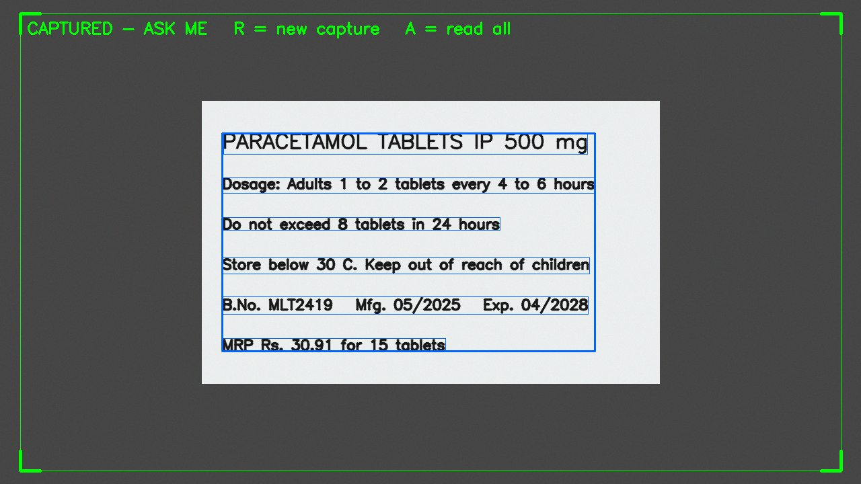
Figure 1. Capture (normal mode): a medicine label has been captured and the user can ask questions.
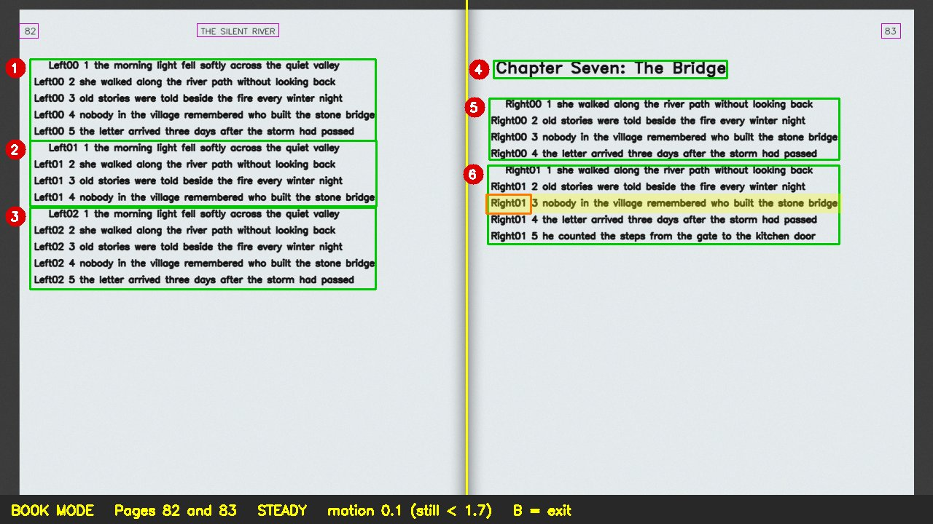
Figure 2. Book mode: page numbers and running title outlined (announced, not read), paragraphs numbered in reading order, spoken line and word highlighted.

9. Backend specifications
Item | Your specification | Version
Language | Python (desktop: one process with worker threads; cloud: FastAPI server in a Docker container) | Desktop 3.13; cloud container 3.11
Web framework | Desktop: none (no HTTP server). Web version: FastAPI with Uvicorn (server.py) | Pinned in requirements-cloud.txt
LLM orchestration | Direct HTTP calls to the Ollama REST API (streaming) with a custom request router; no framework | requests 2.34.2
Model serving | Desktop: Ollama on the laptop, qwen2.5:7b-instruct; OCR by Apple Vision (pyobjc). Cloud: Ollama on CPU in the Space, qwen2.5:3b-instruct; OCR by RapidOCR | Ollama 0.23.2; pyobjc 12.2.2
Relational / document DB | None — desktop state is held in memory; the web server keeps per-session state in memory keyed by a document id and discards it after 30 minutes | —
Vector DB | None — no retrieval index (captured text fits in the context window) | —
Cache / queue | In-process queues and threads: camera frame buffer, request queue, speech queue | Python standard library
File / object storage | None — frames and text are not saved | —
Authentication | None — desktop is single-user; the public web demo has no login and is rate-limited per session | —
Secrets management | Local .env file (git-ignored, python-dotenv); in the cloud, Hugging Face Space secrets and variables; nothing committed to Git | —

API endpoints: the first four are exposed by the web version's server (server.py); the remaining rows are external services called by the applications.
Method | Endpoint | Purpose | Request → Response | Auth
POST | /api/capture | OCR a photo from the browser | multipart image → {doc_id, text, page_facts} | No (public demo, rate-limited)
POST | /api/ask | Answer a question about the captured text | {doc_id, question} → streamed answer sentences | No (public demo, rate-limited)
POST | /api/search | Web lookup after the user agrees | {doc_id, question} → streamed answer labelled "According to the web" | No (public demo, rate-limited)
GET | /api/health | Health check for the deployment | — → {status: ok} | No
POST | localhost:11434/api/chat (Ollama) | Generate a streamed answer | {model, messages, stream: true, options} → JSON lines {message.content, done} | No (local)
POST | localhost:11434/api/generate (Ollama) | Load the model at start-up | {model, keep_alive} → {done} | No (local)
POST | Google Speech Recognition (desktop) | Speech to text | audio → transcript | Library default key
GET | DuckDuckGo search (ddgs) | Web lookup after consent | query → top 5 {title, body, href} | No

Database schema: Not applicable — no database. In-memory state: captured text with page facts, the last six question–answer pairs, the current page layout (line and word boxes with character offsets) and the reading position. The web server holds the same state per session, keyed by doc_id, for up to 30 minutes.

10. Architecture diagram
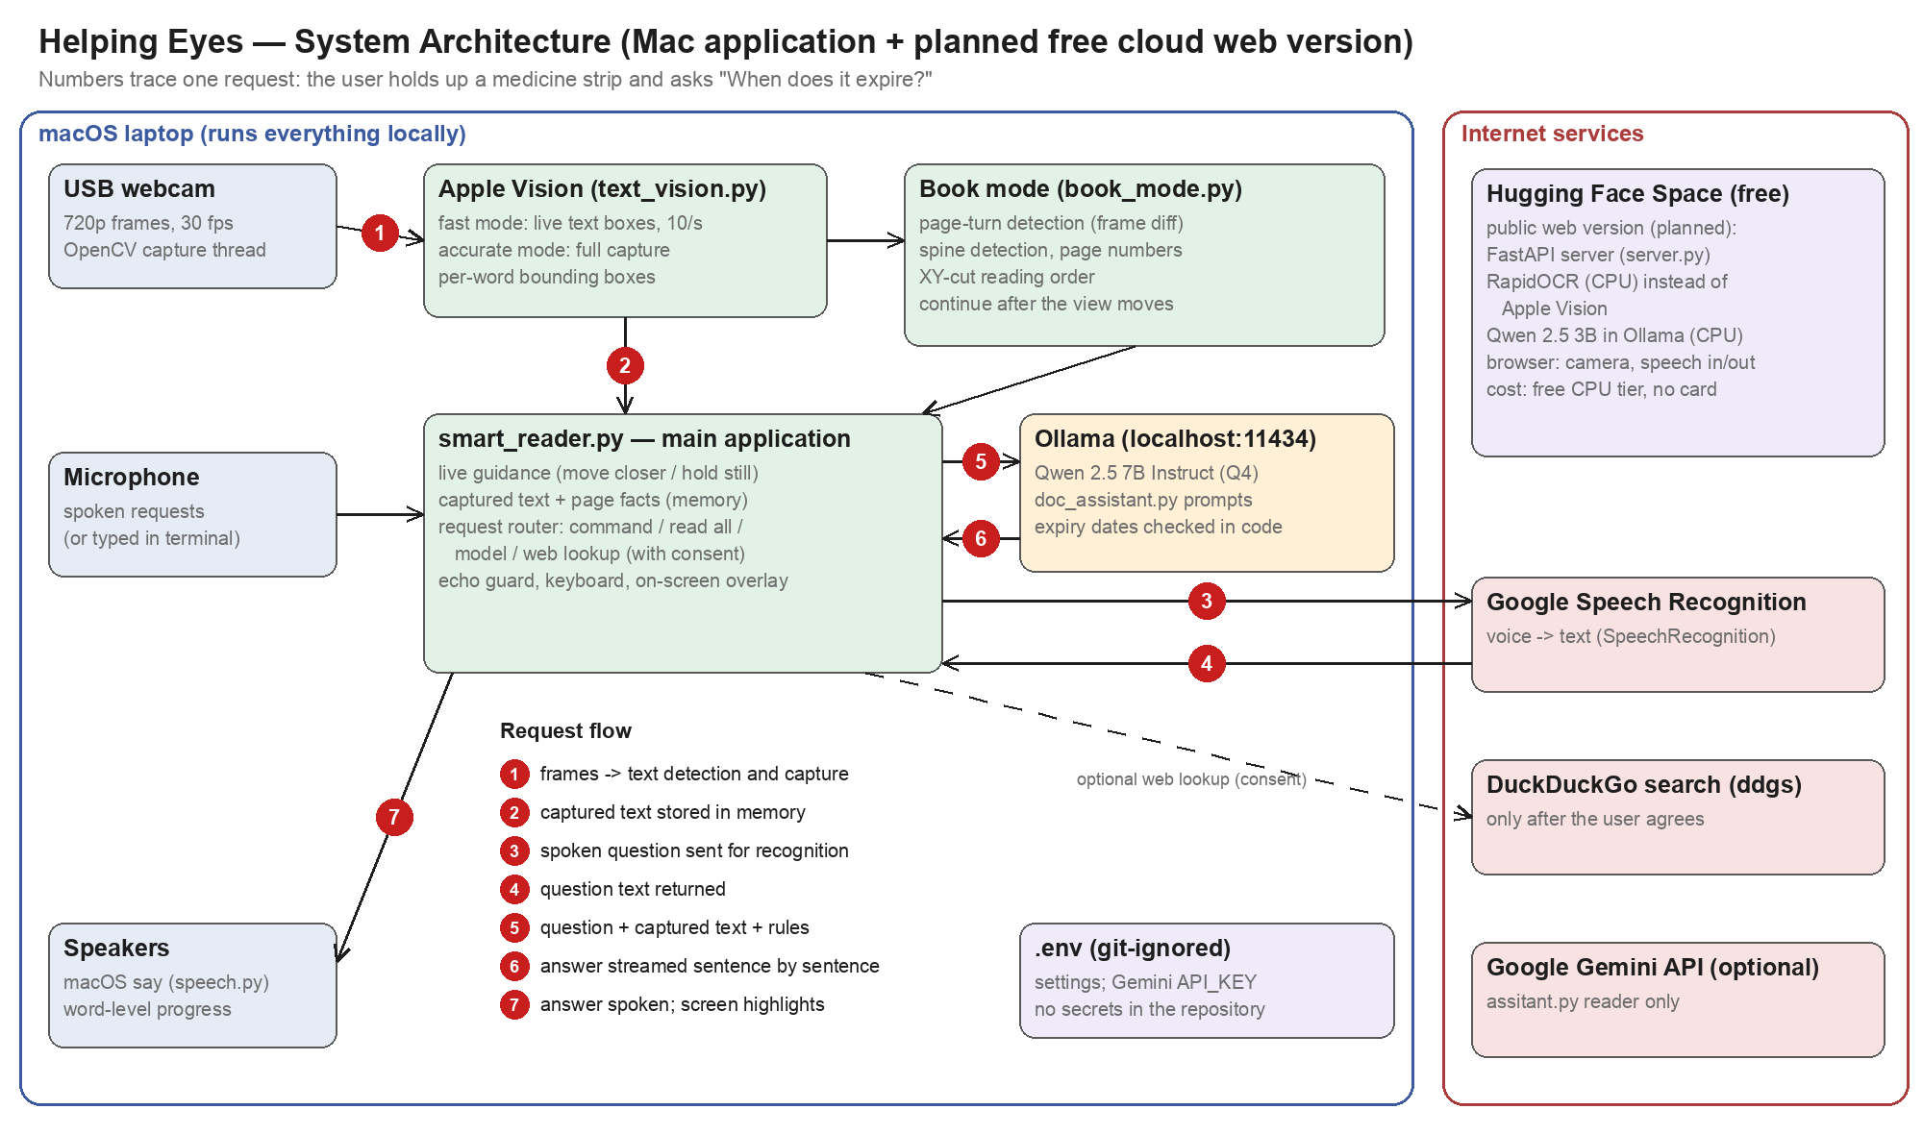
Figure 3. System architecture: the desktop application on one Mac and the planned free cloud web version on Hugging Face Spaces. Numbers trace one request: capture a label and ask "When does it expire?"

Component description:
USB webcam + capture thread (OpenCV): delivers the newest 720p frame; a background thread avoids stale frames.
Apple Vision (text_vision.py): on-device text detection (fast mode, 10 checks per second) and recognition with per-word boxes; chosen for accuracy and ~0.1–0.2 s latency.
Book mode (book_mode.py): own computer vision pipeline — page-turn detection by frame differencing, spine detection, header/footer and page-number recognition, recursive XY-cut reading order, continuation after movement.
Main application (smart_reader.py): guidance, capture, request router, echo guard, keyboard handling and on-screen overlays.
Ollama + Qwen 2.5 7B Instruct (doc_assistant.py): grounded question answering with streamed output; local for privacy and zero cost.
Speech (speech.py): queued, interruptible macOS say with word-level progress used for the reading highlight.
Google Speech Recognition: converts spoken requests to text (online).
DuckDuckGo (ddgs): optional web lookup after consent; no account or key needed.
.env (git-ignored): configuration and the optional Gemini API key; no secrets in the repository.
Google Gemini (assitant.py, optional): an alternative reader that reads all text aloud.
Web version on Hugging Face Spaces (planned, free): FastAPI server with RapidOCR and Qwen 2.5 3B in Ollama on CPU; the browser provides the camera, speech recognition and speech output.

11. Cloud hosting and deployment (mandatory)
Every project must be deployed on a public cloud and reachable by a public URL for the final demo. A laptop-only or Colab-only demo does not meet this requirement.
Item | Your specification
Cloud provider | Hugging Face Spaces, free "CPU basic" hardware (2 vCPU, 16 GB RAM). The desktop application remains the full local version.
Free tier / credits used | Free tier only — no credit card, no paid API keys; total cost ₹0
Frontend hosting | Same Space: a static HTML/JavaScript page served by the backend (browser camera via getUserMedia; Web Speech API for speech recognition and synthesis)
Backend hosting | Same Space (Docker SDK): FastAPI application (server.py) run by Uvicorn
LLM hosting | Inside the Space: Ollama on CPU with Qwen 2.5 3B Instruct (4-bit). Fallback if too slow: a free API tier (Groq or Google Gemini)
Managed databases | None required (no database; per-session state in memory)
Containerisation | Dockerfile in the repository (base image python:3.11-slim; installs Ollama, RapidOCR and the Python dependencies; pulls the model on start-up)
CI/CD | Hugging Face rebuilds and redeploys on every git push to the Space; GitHub Actions (free for public repositories) run the compile and test scripts on push
Environment config & secrets | Hugging Face Space secrets and variables (e.g. LLM_MODEL, optional fallback API key); local .env git-ignored; nothing committed
Domain and HTTPS | Provider URL with HTTPS included: https://<username>-helping-eyes.hf.space
Monitoring and logging (LLMOps) | Space container logs; the server logs OCR time, time to the first answer sentence and errors for every request
Estimated monthly cost | ₹0 per month (free CPU Space, open-source model and OCR, free search, browser speech). The Space sleeps after a period without visitors and is opened a few minutes before the demo to wake it
Public demo URL | To be filled after deployment (format: https://<username>-helping-eyes.hf.space)

Deployment steps: Cloud (web version): 1. Create a free Hugging Face account and a new Space (SDK: Docker, hardware: CPU basic). 2. Add the Space as a git remote and push the repository (server.py, web/, Dockerfile, requirements-cloud.txt). 3. Hugging Face builds the container, installs Ollama and RapidOCR and pulls qwen2.5:3b-instruct. 4. Set variables and secrets in the Space settings. 5. Open the Space URL and check /api/health. 6. Before the demo, open the URL a few minutes early to wake the Space. Desktop application: brew install python@3.13 portaudio and Ollama; ollama pull qwen2.5:7b-instruct; install requirment.txt in a virtual environment; copy .env.example to .env; run python smart_reader.py.
Shutdown plan: No paid resources are used, so no charges can arise. After the evaluation, the Space will be paused or made private in its settings.

12. Risks and mitigation
Risk | Likelihood (L/M/H) | Impact (L/M/H) | Mitigation / fallback
Answers on the free cloud CPU are slow (several seconds; long pages longer) | M | M | Qwen 2.5 3B instead of 7B, short prompts, a "One moment" message; fallback to a free API tier (Groq or Gemini); the desktop application is the primary demo
Free Space sleeps or free-tier limits change before the demo | M | M | Open the URL a few minutes before the demo; keep a backup recording; demonstrate the desktop application as well
Cloud OCR (RapidOCR) is less accurate than Apple Vision | M | M | Measure both on the same test set; guide the user to hold the item steady and close; ask to read everything to check
OCR errors on curved, glossy or blurred print lead to wrong answers | M | H | Hold-still capture, spoken guidance, answers only from captured text; user can ask to read everything to check
Wrong or invented medical details from the language model | M | H | Grounding rules, not-in-text tag, expiry computed in code, pharmacist reminder
No internet: speech recognition, web lookup and the web version unavailable | M | M | Desktop typed requests and keys work offline; evaluate on-device speech recognition (OQ-3)
DuckDuckGo rate limits or library changes | M | L | Spoken error message; switch to another free search source if needed
7B model too slow or too large on lower-end Macs | L | M | Smaller model (qwen2.5:3b) via the LLM_MODEL setting
Microphone captures the application's own voice | L | M | Echo guard implemented (recordings overlapping speech are discarded); S key stops speech

13. Timeline and milestones
Week | Milestone | Deliverable | Owner
1–2 | Requirements approved | This document, signed off | [Name]
3–4 | Test set collected, baseline running | Baseline results: OCR, answers, book mode | [Name]
5–7 | Core pipeline complete (local prototype already working); web version (server.py, web page, Dockerfile) and first deployment on Hugging Face Spaces | Working prototype on a public URL | [Name]
8–9 | Evaluation and improvement | Metrics table filled | [Name]
10 | Final submission | Live cloud demo URL, report, code, slides | All

14. Final deliverables
- Source code in a public or instructor-shared GitHub repo with a README and setup steps
- Working demo on the deployed public cloud URL (5–7 minutes), plus a backup recording
- Final report with evaluation results mapped to FR/NFR IDs
- Presentation slides
- Individual contribution statement from each member

15. Open questions
- OQ-1 (decided 26-09-2026) Cloud deployment: free Hugging Face Space with FastAPI, RapidOCR and Qwen 2.5 3B Instruct; the browser handles the camera and speech. Remaining: confirm on the deployed Space that answer latency meets NFR-1; if not, switch the cloud model to a free API tier (Groq or Gemini). Owner: [Name]; by [DD-MM-YYYY].
- OQ-2 Collection and labelling of the real-world test set (30 items, 60 questions, 20 expiry dates, 10 book spreads). Owner: [Name]; by [DD-MM-YYYY].
- OQ-3 On-device speech recognition (e.g. Apple Speech framework or Whisper) to remove the internet dependency for spoken requests. Owner: [Name]; by [DD-MM-YYYY].
- OQ-4 Whether the optional Gemini reader (assitant.py) remains in the final submission. Owner: [Name]; by [DD-MM-YYYY].
- OQ-5 Adding the synthetic book-mode test scripts to the repository so results can be reproduced. Owner: [Name]; by [DD-MM-YYYY].

16. Change log
Date | Version | Change | Reason
26-09-2026 | v0.1 | Initial requirements document | First submission for sign-off
26-09-2026 | v0.2 | Cloud deployment decided: free Hugging Face Space (Section 11); web version added (FR-13, new user type and screen); LLM, data, NFR, evaluation, backend, endpoints, architecture, risks, timeline and OQ-1 updated | Cloud deployment is mandatory; all components must be free

17. Sign-off
Role | Name | Signature | Date
Team lead | [Name]
Faculty mentor | [Name]

